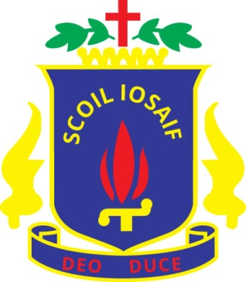

List of Headmasters/Principals of St Joseph’s

1890 Br. J.M. Costen
1900 Br. J.V. Casey
1905 Br. J.A. Browne
1916 Br. M.L. O’Donoghue
1917 Br. J.A. Mulholland
1920 Br. M.L. O’Donoghue
1926 Br. S. McGovern
1927 Br. J.C. Wilson
1931 Br. S. McGovern
1932 Br. L. Curran
1934 Br. W.B. Kennedy
1937 Br. T.G. Russell
1939 Br. T.M. Keane
1944 Br. M.F. O’Donoghue
1951 Br. T.P Condon

1956 Br. M.N. Geraghty
1960 Br. D.P. Manning
1962 Br. P.L. Brady
1965 Br. J.A. McCaffrey
1969 Br. T.P. Feeney
1973 Br. T.T. Devane
1974 Br. J.L. Hannigan
1978 Br. J.M. Fahy
1986 Mr. Michael Foster
1999 Mr. Aidan Giblin
2000 Mr. John Keane
2001 Mr. Brian O’Dwyer
2010 Mr. Gerard Cullen

