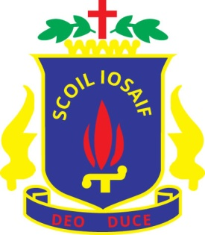

1st Meeting – 15/09/2015
Agenda:
1) Welcome Back
3) State of Council (Resignations, Sixth Years left, etc.)
2) Elect Cabinet & 1st Years
3) Prefects
4) Council Members at Open Evening
5) Briefly discuss matters for this year (Mental Health/Bullying Campaign, Non-Uniform, etc.)
6) Training Days – Emmaus, I.S.S.U.
7) Garda Age Card
8) Any Other Business
An Garda Síochána is actively promoting the Age Card as the preferred form of identification for those aged 18 yrs and over. The Age Card is issued under the Intoxicating Liquor Act of 1988 and is a “proof of age” card to prove that the holder is legally old enough to purchase alcohol.
The card shows:
- Name
- Date of Birth
- Photograph
- Numerous security features to ensure its validity.
To apply for a card the Applicant needs the following:
- A Birth Certificate or a Passport or a GNIB card.
- One other form of ID
- One colour passport photograph.
- €10 payment from a credit/debit card or an Age Card Voucher (Voucher can be purchased in any Post Office)
Students may also get details and a link to the Age Card website on www.drinkaware.ie in the Be Aware section and also on the links page. Further details and the online application forms are available on www.agecard.ie

